RESTFUL-SERVICE EXERCISE

- Create a simple REST ful service in Spring Boot which returns the Response "Welcome to spring boot".

package com.example.RestfulServices;
import org.springframework.web.bind.annotation.RequestMapping;
import org.springframework.web.bind.annotation.RequestMethod;
import org.springframework.web.bind.annotation.RestController;
@RestController
public class Welcometospringboot
{
@RequestMapping(method = RequestMethod.GET,path="/welcometospring")
public String WelcometoSpring()
{
return "Welcome to Spring Boot";
}
}

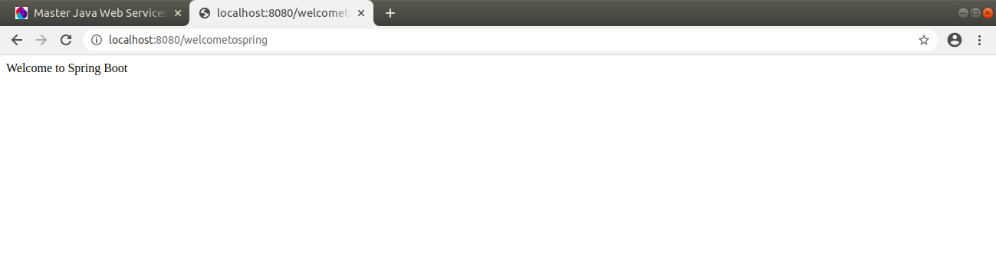

- Create an Employee Bean(id, name, age) and service to perform different operations related to employee.
- Implement GET http request for Employee to get list of employees.
- Implement GET http request using path variable top get one employee
- Implement POST http request for Employee to create a new employee
- Implement Exception Handling for resource not found
- Implement DELETE http request for Employee to delete employee
- Implement PUT http request for Employee to update employee
- Apply validation while create a new employee using POST http Request.

Employee.java

package com.example.RestfulServices.user;
import javax.validation.constraints.Min;
import javax.validation.constraints.NotBlank;
import javax.validation.constraints.NotNull;
import javax.validation.constraints.Size;
public class Employee
{
private Integer id;
@NotBlank(message = "Name cannot be empty")
@Size(min = 4 ,message = "Name should atleast contain 4 alphabets")
String name;
@NotNull
@Min(18)
private int age;
protected Employee() //so that java can create object and then can pass properties to it as java does not know//
{
}
public Employee(Integer id, String name, int age) {
this.id = id;
this.name = name;
this.age = age;
}
public Integer getId() {
return id;
}
public void setId(Integer id) {
this.id = id;
}
public String getName() {
return name;
}
public void setName(String name) {
this.name = name;
}
public int getAge() {
return age;
}
public void setAge(int age) {
this.age = age;
}
@Override
public String toString() {
return "Employee{" + "id=" + id + ", name='" + name + '\'' + ", age=" + age + '}';
}
}

EmployeeDaoService.java

package com.example.RestfulServices.user;
import org.springframework.stereotype.Component;
import org.springframework.web.bind.annotation.PathVariable;
import java.util.ArrayList;
import java.util.Iterator;
import java.util.List;
@Component
public class EmployeeDaoService {
private static int Count = 4;
private static List<Employee> employeeList = new ArrayList<>();
static {
employeeList.add(new Employee(1, "Neha", 23));
employeeList.add(new Employee(2, "Ashu", 22));
employeeList.add(new Employee(3, "Joshit", 20));
employeeList.add(new Employee(4, "Shreya", 21));
}
public List<Employee> findAll() {
return employeeList;
}
public Employee save(Employee employee) {
if (employee.getId() == null) {
employee.setId(++Count);
}
employeeList.add(employee);
return employee;
}
public void UpdateEmployee(Employee employee)
{
employee.setName("Head" +employee.getName());
}
public Employee findOne(int id) {
for (Employee employee : employeeList) {
if (employee.getId() == id) {
return employee;
}
}
return null;
}
public Employee deleteById(int id) {
Iterator<Employee> iterator = employeeList.iterator();
while (iterator.hasNext()) {
Employee employee = iterator.next();
{
if (employee.getId() == id) {
iterator.remove();
return employee;
}
}
}
return null;
}
}

EmployeeResource.java

package com.example.RestfulServices.user;
import org.hibernate.procedure.internal.Util;
import org.springframework.beans.factory.annotation.Autowired;
import org.springframework.http.HttpStatus;
import org.springframework.http.ResponseEntity;
import org.springframework.web.bind.annotation.*;
import org.springframework.web.servlet.support.ServletUriComponentsBuilder;
import javax.validation.Valid;
import java.net.URI;
import java.nio.file.attribute.UserPrincipalNotFoundException;
import java.util.List;
@RestController
public class EmployeeResource
{
@Autowired
private EmployeeDaoService service;
@GetMapping("/users")
public List<Employee> retrieveAllUsers()
{
return service.findAll();
}
@GetMapping("/users/{id}")
public Employee retrieveuser(@PathVariable int id)
{
Employee employee= service.findOne(id);
if(employee==null)
{
throw new UserNotFoundException("id-" +id);
}
return employee;
}
@DeleteMapping("/users/{id}")
public void deleteEmpoyee(@PathVariable int id)
{
Employee employee= service.deleteById(id);
if(employee==null)
{
throw new UserNotFoundException("id-" +id);
}
}
@PostMapping("/users")
public ResponseEntity<Object> CreateUser( @Valid @RequestBody Employee employee)
{
Employee SavedUser=service.save(employee);
URI location= ServletUriComponentsBuilder.fromCurrentRequest()
.path("/{id}").
buildAndExpand(SavedUser.getId()).toUri();
return ResponseEntity.created(location).build();
}
@PutMapping("/users/{id}")
public void updateEmployee(@PathVariable int id ) {
Employee employee1 = service.findOne(id);
if (employee1 == null)
{
throw new UserNotFoundException("id-" + id);
}
service.UpdateEmployee(employee1);
}
}

ExceptionResource.java

package com.example.RestfulServices.user.exception;
import java.util.Date;
public class ExceptionResource
{
private Date timestampdate;
private String message;
private String detail;
public ExceptionResource(Date timestampdate, String message, String detail) {
this.timestampdate = timestampdate;
this.message = message;
this.detail = detail;
}
public Date getTimestampdate() {
return timestampdate;
}
public String getMessage() {
return message;
}
public String getDetail() {
return detail;
}
}
CustomizedException.java

package com.example.RestfulServices.user.exception;
import com.example.RestfulServices.user.UserNotFoundException;
import org.springframework.http.HttpHeaders;
import org.springframework.http.HttpStatus;
import org.springframework.http.ResponseEntity;
import org.springframework.web.bind.MethodArgumentNotValidException;
import org.springframework.web.bind.annotation.ControllerAdvice;
import org.springframework.web.bind.annotation.ExceptionHandler;
import org.springframework.web.bind.annotation.RestController;
import org.springframework.web.context.request.WebRequest;
import org.springframework.web.servlet.mvc.method.annotation.ResponseEntityExceptionHandler;
import java.util.Date;
@ControllerAdvice
@RestController
public class CustomizedExceptionEmployee extends ResponseEntityExceptionHandler
{
@ExceptionHandler(Exception.class)
public final ResponseEntity<Object> handleAllExceptions(Exception ex, WebRequest request)
{
ExceptionResource exceptionResource=new ExceptionResource(new Date(),ex.getMessage(),
request.getDescription(false));
return new ResponseEntity(exceptionResource, HttpStatus.INTERNAL_SERVER_ERROR);
}
@ExceptionHandler(UserNotFoundException.class)
public final ResponseEntity<Object> handleUserNotFoundExceptions(UserNotFoundException ex, WebRequest request)
{
ExceptionResource exceptionResource=new ExceptionResource(new Date(),ex.getMessage(),
request.getDescription(false));
return new ResponseEntity(exceptionResource, HttpStatus.NOT_FOUND);
}
@Override
protected ResponseEntity<Object> handleMethodArgumentNotValid(MethodArgumentNotValidException ex, HttpHeaders headers,
HttpStatus status, WebRequest request) {
ExceptionResource exceptionResource=new ExceptionResource(new Date(),"Validation failed",
ex.getBindingResult().toString());
return new ResponseEntity(exceptionResource, HttpStatus.BAD_REQUEST);
}
}
UserNotFoundException.java

package com.example.RestfulServices.user;
public class UserNotFoundException extends RuntimeException
{
public UserNotFoundException(String s)
{
super(s);
}
}
(Get Request)

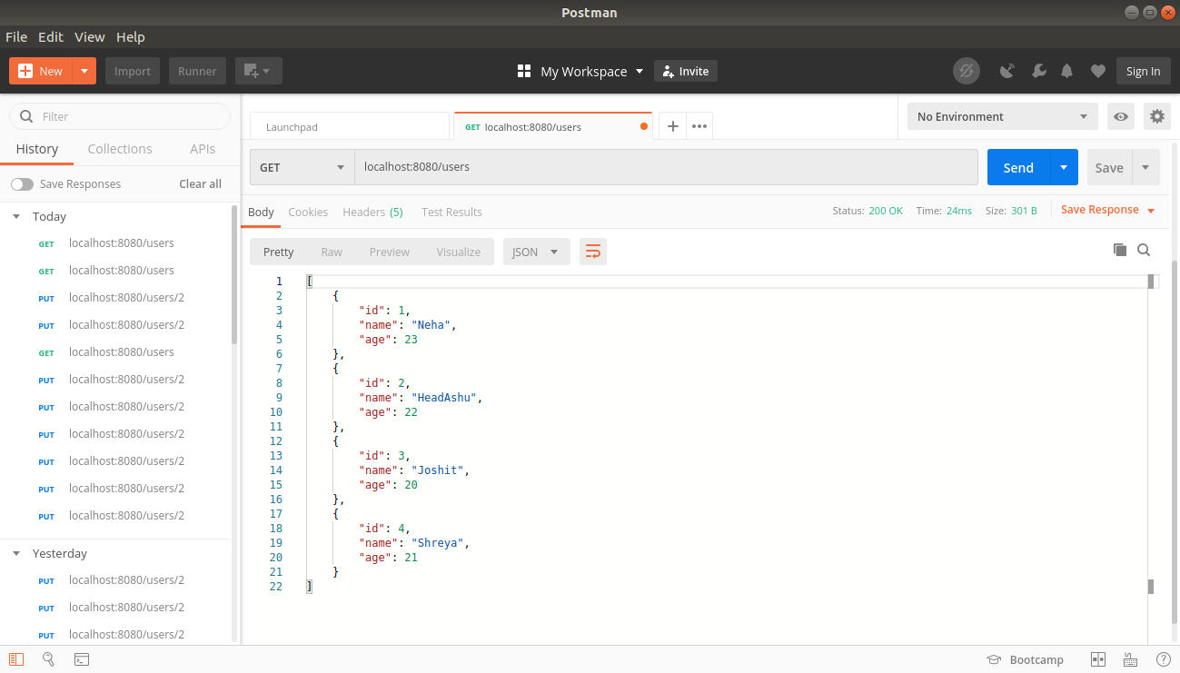

(Post request)

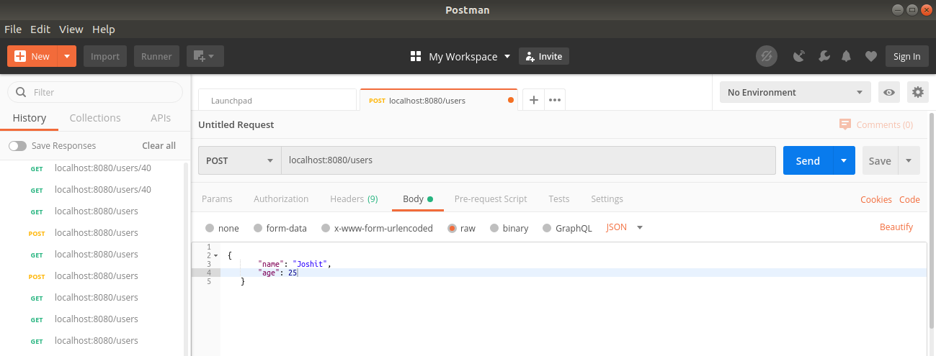
(After post method, the updated list)

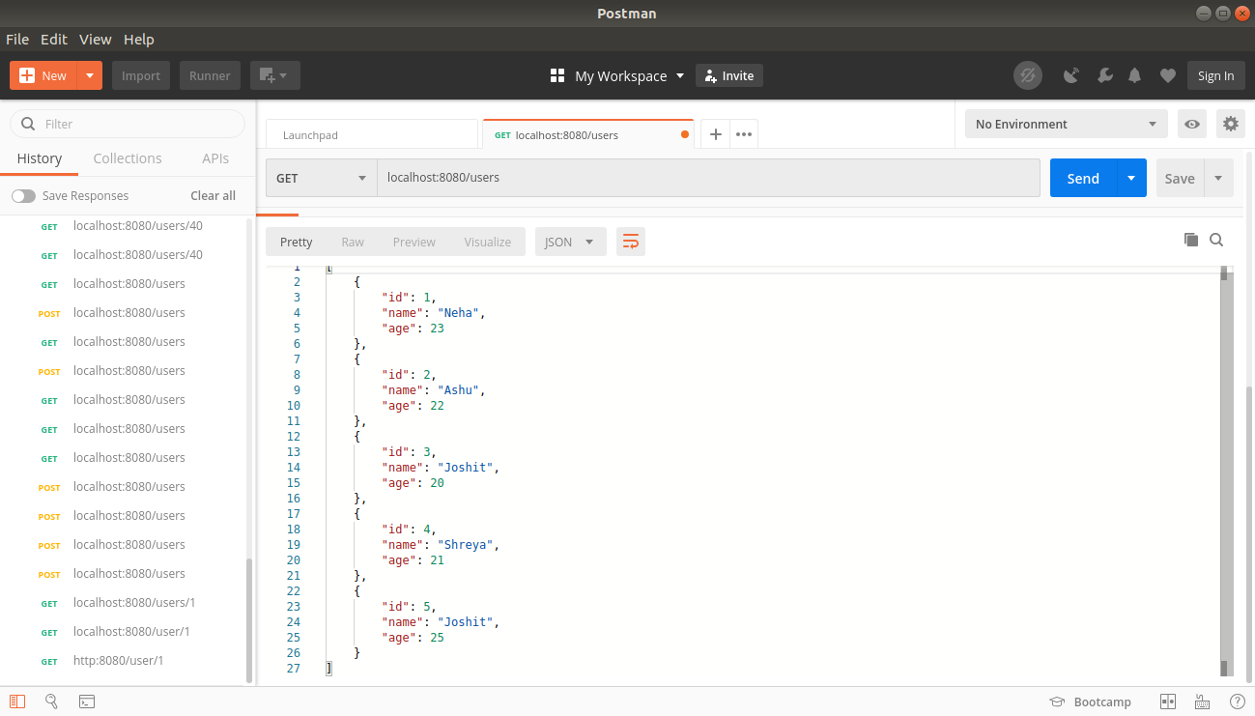

(Delete an Employee)

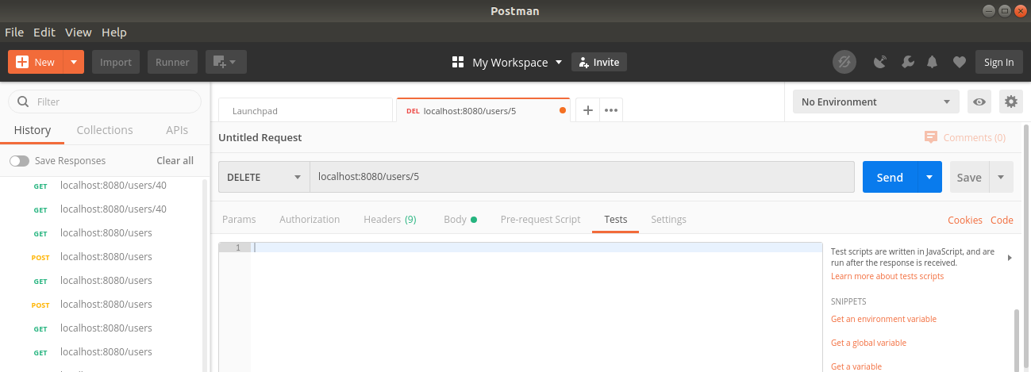
(List of employees after deleting)

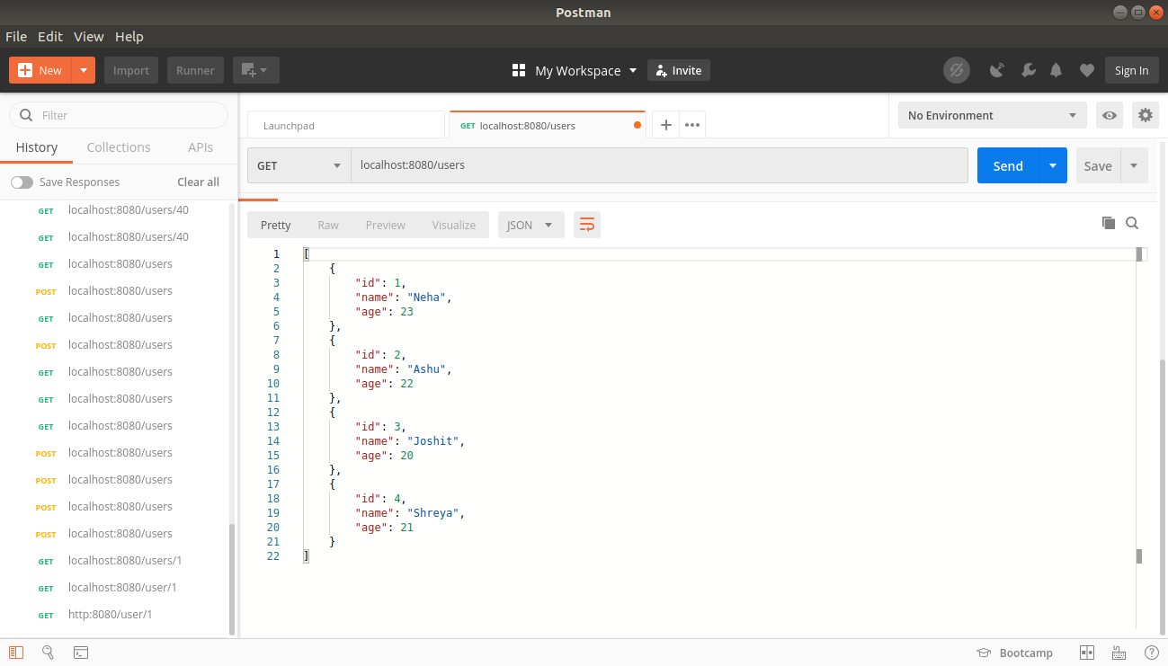

(Put method)

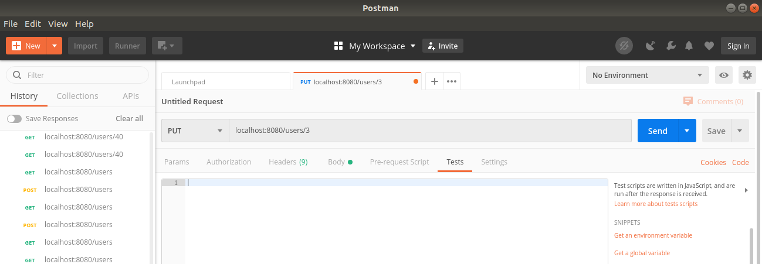
(After put method the list of updated employees)

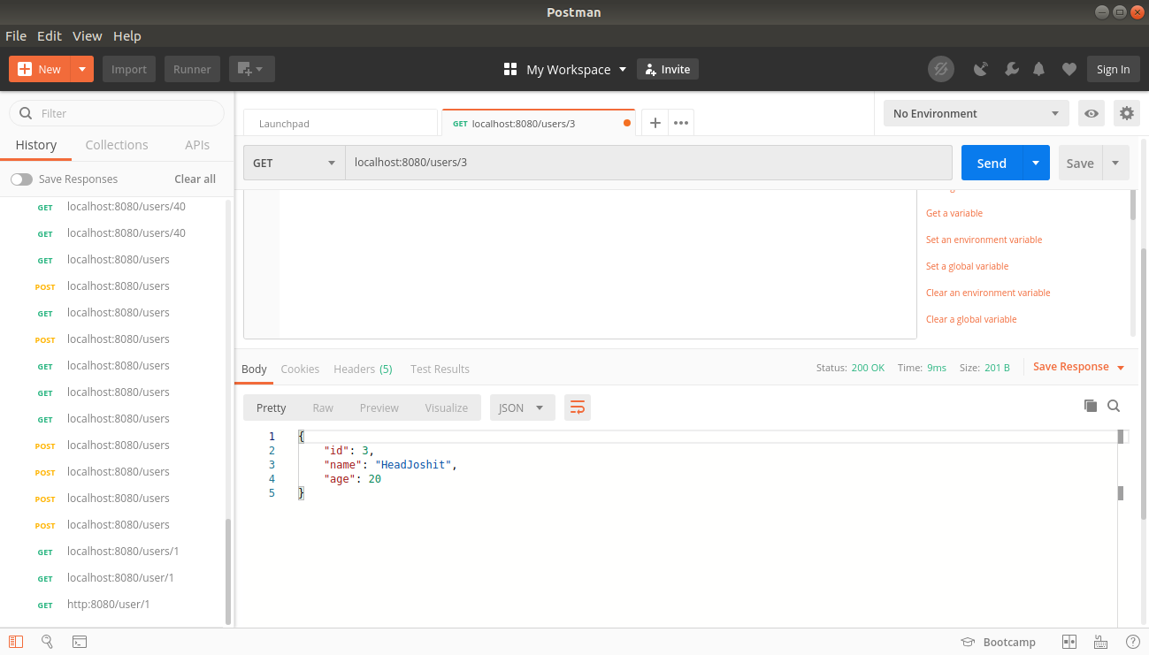

(Exception handling and Validation check)

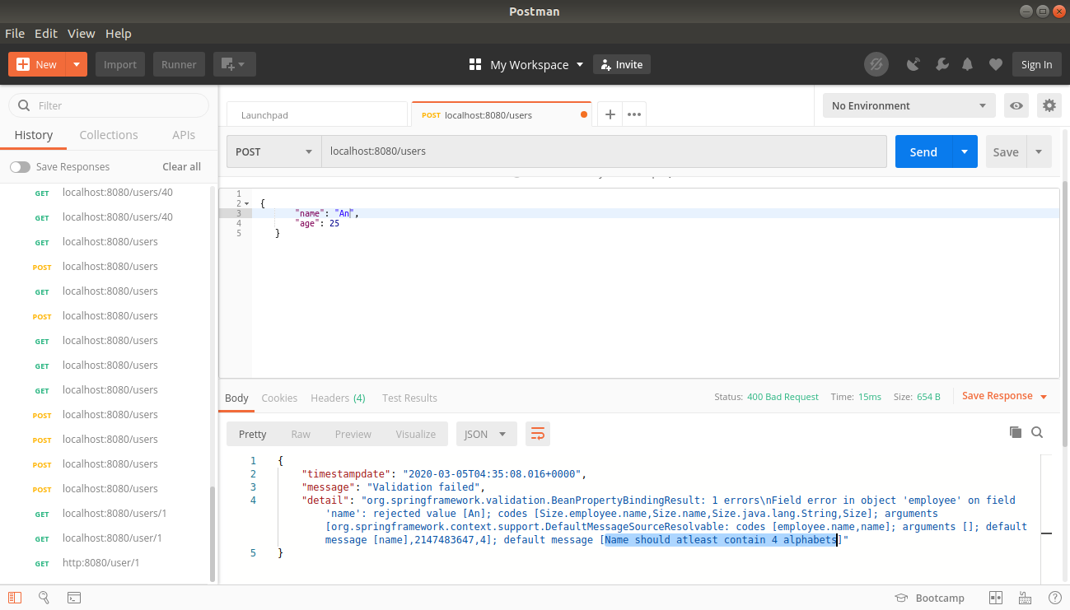

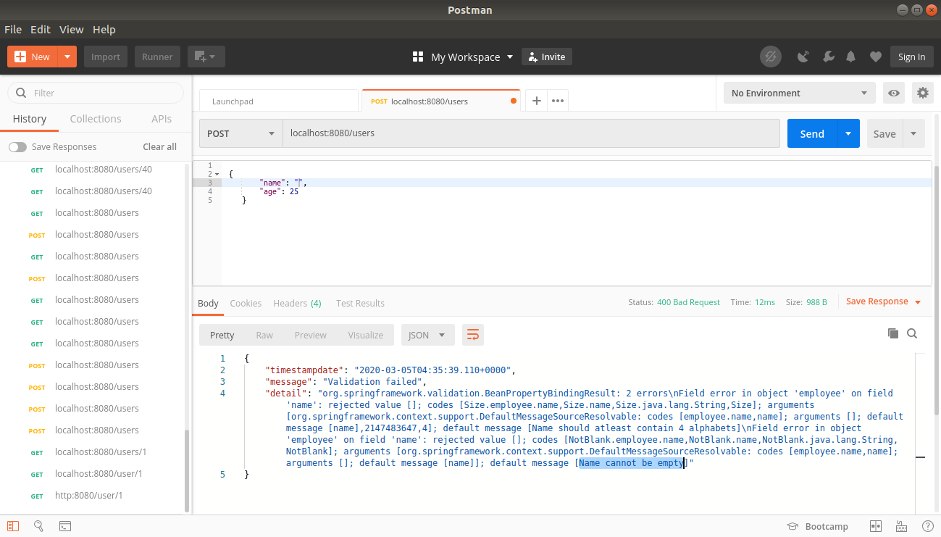

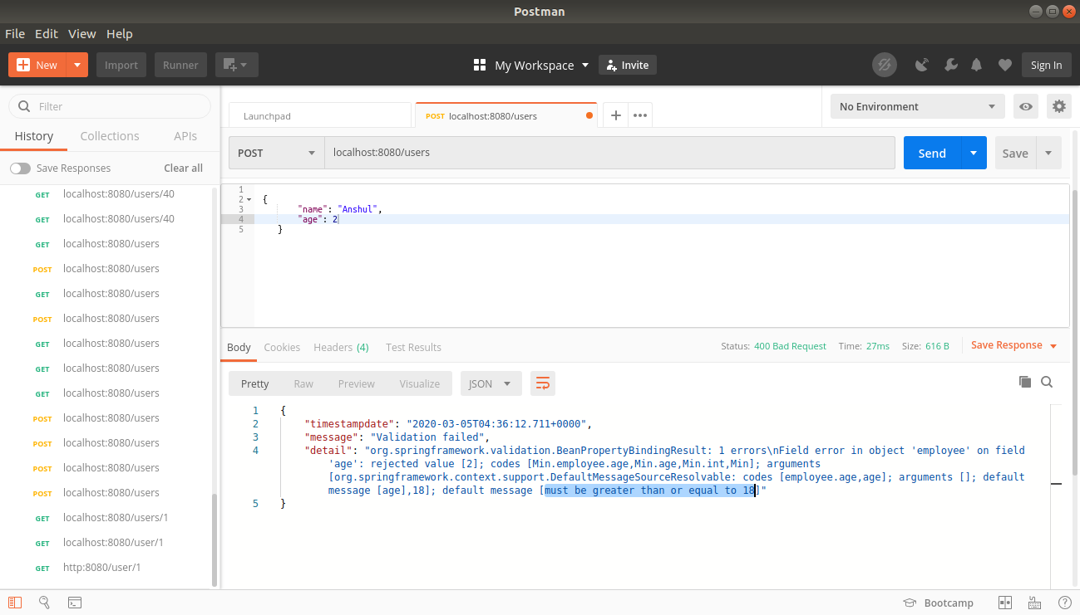

3) Configure actuator in your project to check the health of application and get the information about various beans configured in your application

application.properties

management.endpoints.web.exposure.include=*

(Hal Browser)

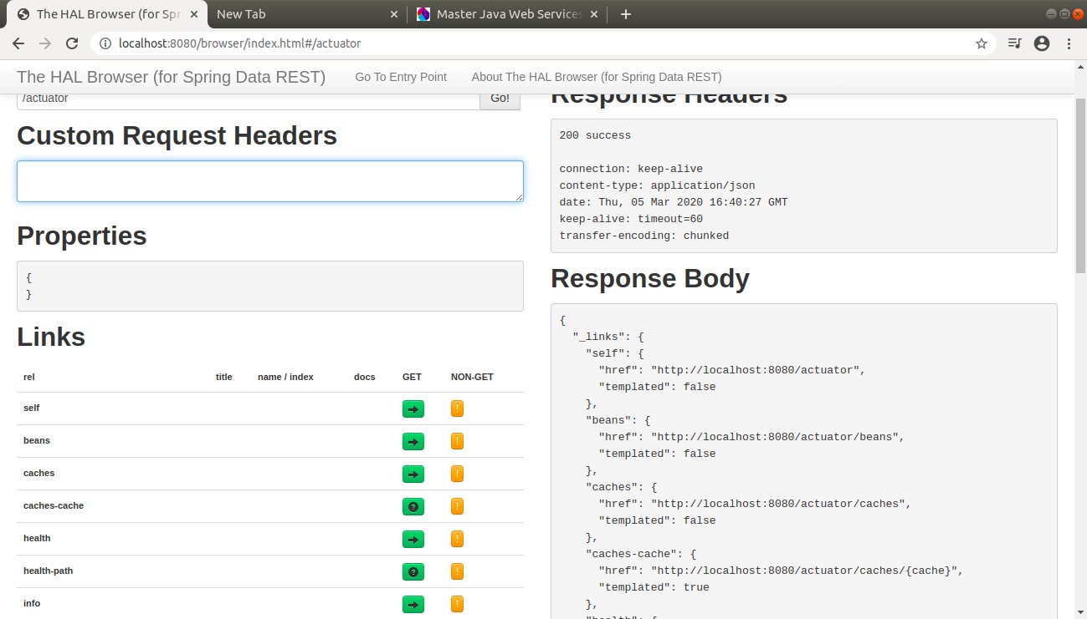

(Actuator)
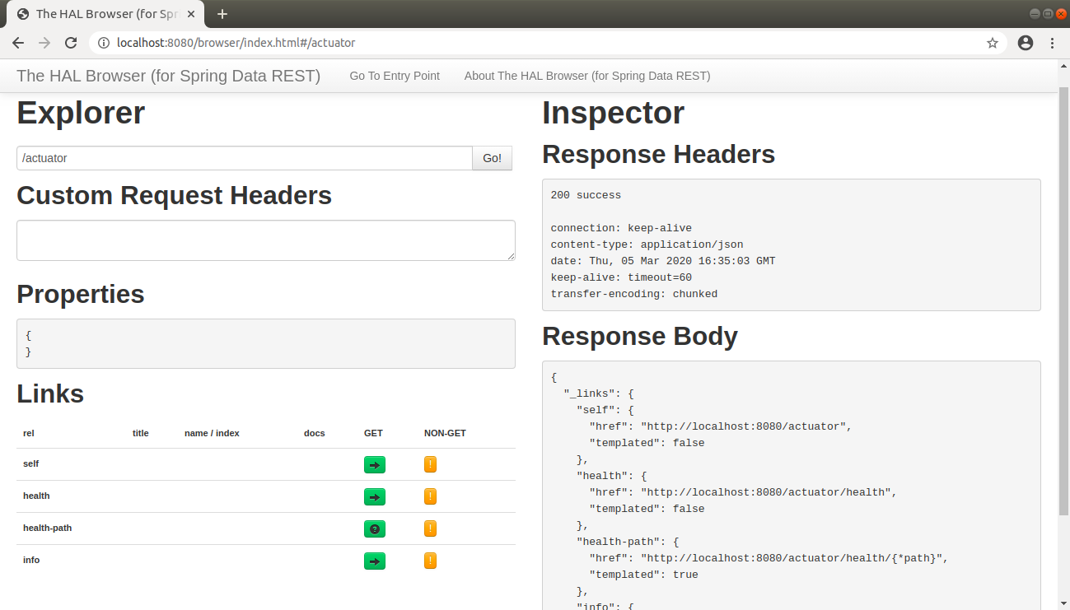

(Health Check)

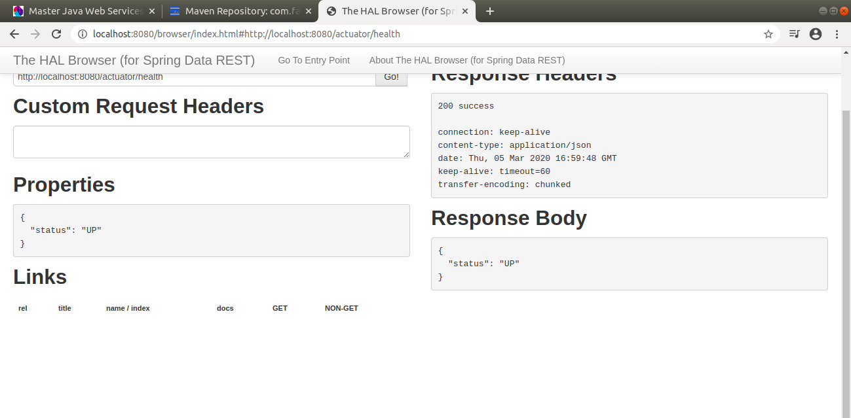

(Bean Information)

